Module 6) JAVASCRIPT BASIC & DOM

# (Basic logic Question)

**Q.1 What is JavaScript. How to use it?**

**Ans.**   
 JavaScript is a programming language used for adding interactivity to web pages. You can include JavaScript code directly in HTML files using **<script>** tags or in external **.js** files , and it enables manipulation of HTML elements and CSS styles to create dynamic content.

**Q.2 How many type of Variable in JavaScript?**

**Ans.**

In JavaScript, there are three types of variables: **var**, **let**, and **const**. **var** has function scope, **let** has block scope, and **const** declares a constant variable that cannot be reassigned.

**Q.3 Define a Data Types in js?**

**Ans.**

JavaScript has several data types, including primitive types like strings, numbers, booleans, null, undefined, and symbol, along with non-primitive types like objects and functions.

**Q.4 Write a mul Function Which will Work Properly When invoked With Following Syntax**

**Ans.**

A **mul** function in JavaScript that utilizes the rest parameter syntax (...) to accept any number of arguments and then multiply them together using the **reduce** method. Here's an **example:**

function mul(...args) {

return args.reduce((acc, val) => acc * val, 1);

}

This function will work properly when invoked with any number of arguments, such as **mul(2, 3, 4)** or **mul(5, 6, 7, 8)**.

**Q.5 What the deference between undefined and undeclare in JavaScript?**

**Ans.**

Undeclared variables are those that have not been declared or defined in the current scope, while undefined variables are those that have been declared but not given a value.

**Q.6 Using console.log() print out the following statement: The quote 'There is no exercise better for the heart than reaching down and lifting people up.' by John Holmes teaches us to help one another. Using console.log() print out the following quote by Mother Teresa:**

**Ans.**

console.log("The quote 'There is no exercise better for the heart than reaching down and lifting people up.' by John Holmes teaches us to help one another.");

console.log(" Mother Teresa");

**Q.7 Check if typeof '10' is exactly equal to 10. If not make it exactly equal?**

**Ans.**

if (typeof '10' !== typeof 10) {

// Convert '10' to a number

var convertedNumber = parseInt('10');

console.log(convertedNumber);

}

**Q.8 Write a JavaScript Program to find the area of a triangle?**

**Ans.**

A JavaScript program to find the area of a triangle using the formula: **Area = (base * height) / 2**.

function triangleArea(base, height) {

return (base * height) / 2;

}

// Example usage:

console.log(triangleArea(5, 8)); // Output: 20

**Q.9 Write a JavaScript program to calculate days left until next Christmas?**

**Ans.**

function daysUntilChristmas() {

// Get today's date

var today = new Date();

// Get the current year

var currentYear = today.getFullYear();

// Set Christmas date for the current year

var christmas = new Date(currentYear, 11, 25);

// If Christmas has already passed this year, set it for next year

if (today.getMonth() === 11 && today.getDate() > 25) {

christmas.setFullYear(currentYear + 1);

}

// Calculate the difference in milliseconds between today and Christmas

var timeDiff = christmas.getTime() - today.getTime();

// Convert milliseconds to days

var daysLeft = Math.ceil(timeDiff / (1000 * 60 * 60 * 24));

return daysLeft;

}

// Example usage:

console.log("Days left until Christmas: " + daysUntilChristmas());

**Q.10 What is Condition Statement?**

**Ans.**

A condition statement is a programming construct used to make decisions based on certain conditions. It typically evaluates an expression and executes a block of code if the condition is true, otherwise it executes an alternative block of code or does nothing. In JavaScript, common condition statements include if statements, switch statements, and ternary operators.

**Q.11 Find circumference of Rectangle formula : C = 4 * a ?**

**Ans.**

The formula provided, *C*=4×*a*, calculates the circumference of a rectangle, where 𝐶represents the circumference and 𝑎*a* is the length of one side.

**Q.12 WAP to convert years into days and days into years?**

**Ans.**

// Convert years to days

function yearsToDays(years) {

return years * 365;

}

// Convert days to years

function daysToYears(days) {

return days / 365;

}

// Example usage:

console.log(yearsToDays(5)); // Convert 5 years to days

console.log(daysToYears(1825)); // Convert 1825 days to years

**Q.13 Convert temperature Fahrenheit to Celsius? (Conditional logic Question)**

**Ans.**

function fahrenheitToCelsius(fahrenheit) {

return (fahrenheit - 32) * 5 / 9;

}

// Example usage:

console.log(fahrenheitToCelsius(32)); // Convert 32°F to Celsius

**Q.14 Write a JavaScript exercise to get the extension of a filename.?**

**Ans.**

function getFileExtension(filename) {

return filename.slice(filename.lastIndexOf('.') + 1);

}

// Example usage:

console.log(getFileExtension("example.txt")); // Output: "txt"

This function extracts the extension from the filename by finding the last occurrence of the period (.) and slicing the string from that position to the end.

**Q.15 What is the result of the expression (5 > 3 && 2 < 4)?**

**Ans.**

True

**Q.16 What is the result of the expression (true && 1 && "hello")?**

**Ans.**

**"hello"**

**Q.17 What is the result of the expression true && false || false && true?**

**Ans.**

**False**

**Q.18 What is a Loop and Switch Case in JavaScript define that ?**

**Ans.**

A loop in JavaScript is a programming construct that repeatedly executes a block of code until a specified condition is met. Common types of loops include for, while, and do-while loops.

A switch case statement in JavaScript is a control flow statement that evaluates an expression and executes a block of code depending on the value of the expression. It provides an alternative to multiple if...else statements when there are multiple possible conditions to consider.

**Q.19 What is the use of is Nan function?**

**Ans.**

The **isNaN()** function in JavaScript is used to determine whether a value is NaN (Not-a-Number) or not. It returns **true** if the value is NaN, and **false** otherwise.

**Q.20 What is the difference between && and || in JavaScript?**

**Ans.**

In JavaScript, **&&** is the logical AND operator, which returns true only if both operands are true. Conversely, **||** is the logical OR operator, which returns true if at least one of the operands is true.

**Q.21 What is the use of Void (0)?**

**Ans.**

The use of **void(0)** in JavaScript is to create an undefined value. It's commonly used in anchor tags (**<a>**) to prevent the browser from following the link when clicked, effectively making it act as a placeholder link or a JavaScript pseudo-protocol.

**Q.22 Check Number Is Positive or Negative in JavaScript?**

**Ans.**

function checkNumber(num) {

if (num > 0) {

return "Positive";

} else if (num < 0) {

return "Negative";

} else {

return "Zero";

}

}

// Example usage:

console.log(checkNumber(5)); // Output: "Positive"

console.log(checkNumber(-3)); // Output: "Negative"

console.log(checkNumber(0)); // Output: "Zero"

**Q.23 Find the Character Is Vowel or Not ?**

**Ans.**

function isVowel(char) {

return 'aeiouAEIOU'.indexOf(char) !== -1;

}

// Example usage:

console.log(isVowel('a')); // Output: true

console.log(isVowel('z')); // Output: false

**Q.24 Write to check whether a number is negative, positive or zero?**

**Ans.**

function checkNumber(num) {

if (num > 0) {

return "Positive";

} else if (num < 0) {

return "Negative";

} else {

return "Zero";

}

}

// Example usage:

console.log(checkNumber(5)); // Output: "Positive"

console.log(checkNumber(-3)); // Output: "Negative"

console.log(checkNumber(0)); // Output: "Zero"

**Q.25 Write to find number is even or odd using ternary operator in JS?**

**Ans.**

function checkEvenOrOdd(num) {

return num % 2 === 0 ? "Even" : "Odd";

}

// Example usage:

console.log(checkEvenOrOdd(4)); // Output: "Even"

console.log(checkEvenOrOdd(7)); // Output: "Odd"

**Q.26 Write find maximum number among 3 numbers using ternary operator in JS?**

**Ans.**

function findMax(num1, num2, num3) {

return num1 > num2 ? (num1 > num3 ? num1 : num3) : (num2 > num3 ? num2 : num3);

}

// Example usage:

console.log(findMax(10, 5, 8)); // Output: 10

console.log(findMax(3, 12, 7)); // Output: 12

**Q.27 Write to find minimum number among 3 numbers using ternary operator in JS?**

**Ans.**

function findMax(num1, num2, num3) {

return num1 > num2 ? (num1 > num3 ? num1 : num3) : (num2 > num3 ? num2 : num3);

}

// Example usage:

console.log(findMax(10, 5, 8)); // Output: 10

console.log(findMax(3, 12, 7)); // Output: 12

**Q.28 Write to find the largest of three numbers in JS?**

**Ans.**

function findLargest(num1, num2, num3) {

if (num1 >= num2 && num1 >= num3) {

return num1;

} else if (num2 >= num1 && num2 >= num3) {

return num2;

} else {

return num3;

}

}

// Example usage:

console.log(findLargest(10, 5, 8)); // Output: 10

console.log(findLargest(3, 12, 7)); // Output: 12

**Q.29 Write to show**

**i. Monday to Sunday using switch case in JS?**

**Ans.**

function getDayName(dayNumber) {

switch(dayNumber) {

case 1:

return "Monday";

case 2:

return "Tuesday";

case 3:

return "Wednesday";

case 4:

return "Thursday";

case 5:

return "Friday";

case 6:

return "Saturday";

case 7:

return "Sunday";

default:

return "Invalid day number";

}

}

// Example usage:

console.log(getDayName(3)); // Output: "Wednesday"

console.log(getDayName(6)); // Output: "Saturday"

**ii. Vowel or Consonant using switch case in JS?**

**Ans.**

function checkVowelOrConsonant(char) {

switch(char.toLowerCase()) {

case 'a':

case 'e':

case 'i':

case 'o':

case 'u':

return "Vowel";

default:

return "Consonant";

}

}

// Example usage:

console.log(checkVowelOrConsonant('a')); // Output: "Vowel"

console.log(checkVowelOrConsonant('b')); // Output: "Consonant"

**Que -   Create password field with show hide functionalities**

**Ans.**

<!DOCTYPE html>

<html lang="en">

<head>

    <meta charset="UTF-8">

    <meta name="viewport" content="width=device-width, initial-scale=1.0">

    <title>Document</title>

</head>

<body>

    <label for="">Enter Password : </label><input type="password" id="pwd" value="Hello1234">

    <br>

    <br>

    <input type="checkbox" onclick="ShowPassword()" name="" id="check"> <label for="">Password</label>

    <script>

        function ShowPassword() {

            var pwd = document.getElementById("pwd");

            if (pwd.type === "password") {

                pwd.type = "text";

            } else {

                pwd.type = "password"

            }

        }

    </script>

</body>

</html>

**OUTPUT:**

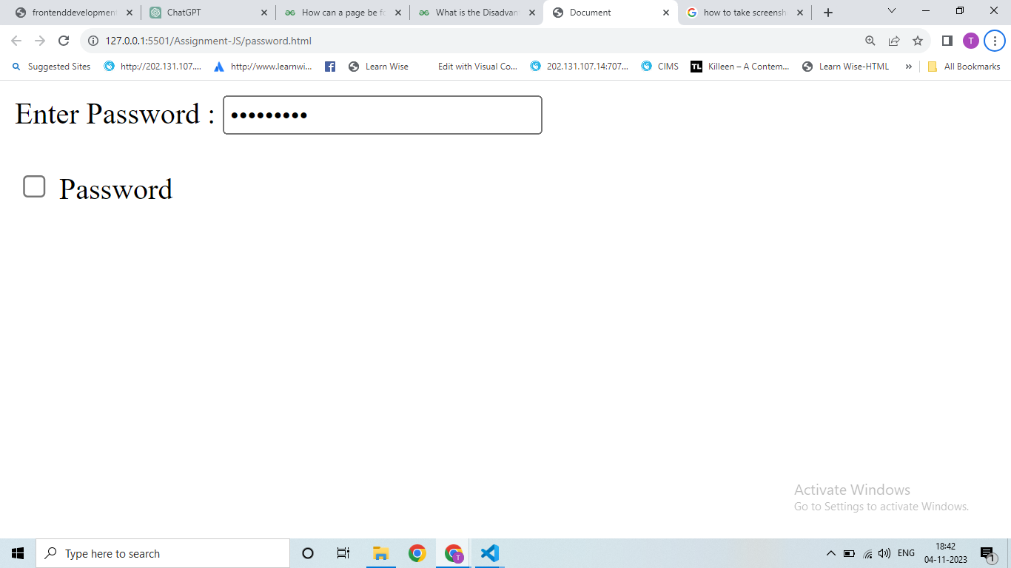

**Que -  Create basic math operation in JS**

**Ans.**

**<!DOCTYPE html>**

**<html lang="en">**

**<head>**

**<meta charset="UTF-8">**

**<meta name="viewport" content="width=device-width, initial-scale=1.0">**

**<title>Document</title>**

**</head>**

**<style>**

**#parent {**

**display: flex;**

**}**

**</style>**

**<body>**

**<h1>Maths Operations</h1>**

**<div>**

**<label for="">Enter 1st Number:</label>**

**<input type="number" id="value1">**

**</div>**

**<div>**

**<label for="">Enter 2nd Number:</label>**

**<input type="number" name="" id="value2">**

**</div>**

**<div id="parent">**

**<div>**

**<button onclick="caculator('+')">+</button>**

**<button onclick="caculator('-')">-</button>**

**<button onclick="caculator('*')">*</button> <br>**

**<button onclick="caculator('/')">/</button>**

**<button onclick="caculator('%')">%</button>**

**</div>**

**<div>**

**<p>Answer is : <span id="result">-</span></p>**

**</div>**

**</div>**

**<script>**

**function caculator(oparators) {**

**var value1 = parseFloat(document.getElementById("value1").value);**

**var value2 = parseFloat(document.getElementById("value2").value);**

**var result = document.getElementById("result");**

**if (isNaN(value1) || isNaN(value2)) {**

**result.textContent = "Invalid Data";**

**} else {**

**switch (oparators) {**

**case "+":**

**result.textContent = (value1 + value2);**

**break;**

**case "-":**

**result.innerHTML = (value1 - value2);**

**break;**

**case "*":**

**result.innerHTML = (value1 * value2);**

**break;**

**case "/":**

**result.innerHTML = (value1 / value2);**

**break;**

**case "%":**

**result.innerHTMLt = ((value1 / 100) * value2);**

**break;**

**default:**

**result.innerHTML = "Invalid Operations"**

**break;**

**}**

**}**

**};**

**</script>**

**</body>**

**</html>**

**OUTPUT:**

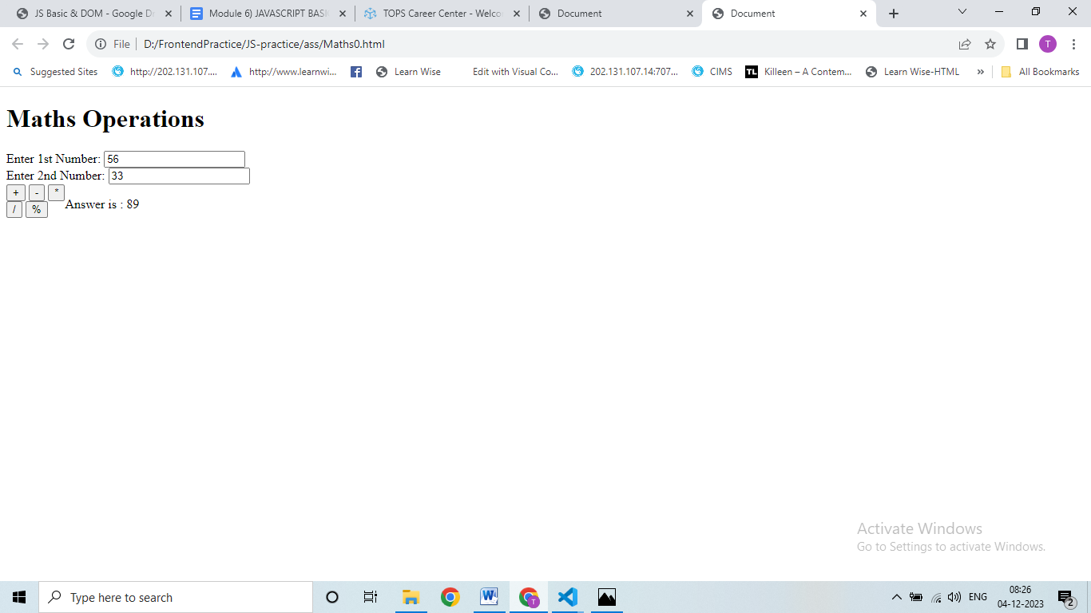

**Que- Create result**

**Ans:**

**<!DOCTYPE html>**

**<html lang="en">**

**<head>**

**<meta charset="UTF-8">**

**<meta name="viewport" content="width=device-width, initial-scale=1.0">**

**<title>Document</title>**

**</head>**

**<body>**

**<fieldset>**

**<table align="center">**

**<h2 align="center">Marksheet for Information Technology</h2>**

**<p align="center">Enter Marks</p>**

**<tr>**

**<td>1.C Language</td>**

**<td><input type="number" id="subject1"></td>**

**</tr>**

**<tr>**

**<td>2.C++ Language</td>**

**<td><input type="number" id="subject2"></td>**

**</tr>**

**<tr>**

**<td>3.Database</td>**

**<td><input type="number" id="subject3"></td>**

**</tr>**

**<tr>**

**<td>4.HTML</td>**

**<td><input type="number" id="subject4"></td>**

**</tr>**

**<tr>**

**<td>5.CSS</td>**

**<td><input type="number" id="subject5"></td>**

**</tr>**

**<tr>**

**<td>6.php</td>**

**<td><input type="number" id="subject6"></td>**

**</tr>**

**<tr>**

**<td>7.Core java</td>**

**<td><input type="number" id="subject7"></td>**

**</tr>**

**<tr>**

**<td></td>**

**<td><button onclick="result()">Result</button></td>**

**</tr>**

**<tr>**

**<td>Total is: <span id="total"></span></td>**

**<td>Percentage is : <span id="percentage"></span></td>**

**</tr>**

**</table>**

**</fieldset>**

**<script>**

**function result() {**

**//get Subject Marks**

**var subject1 = parseFloat(document.getElementById("subject1").value) || 0;**

**var subject2 = parseFloat(document.getElementById("subject2").value) || 0;**

**var subject3 = parseFloat(document.getElementById("subject3").value) || 0;**

**var subject4 = parseFloat(document.getElementById("subject4").value) || 0;**

**var subject5 = parseFloat(document.getElementById("subject5").value) || 0;**

**var subject6 = parseFloat(document.getElementById("subject6").value) || 0;**

**var subject7 = parseFloat(document.getElementById("subject7").value) || 0;**

**//get total & percentage**

**var total = subject1 + subject2 + subject3 + subject4 + subject5 + subject6 + subject7**

**var percentage = (total / 700) * 100;**

**//update the result in HTML**

**document.getElementById("total").innerHTML = total + "/700"**

**document.getElementById("percentage").innerHTML = total / 700 * 100 + "%"**

**}**

**</script>**

**</body>**

**</html>**

**OUTPUT:**

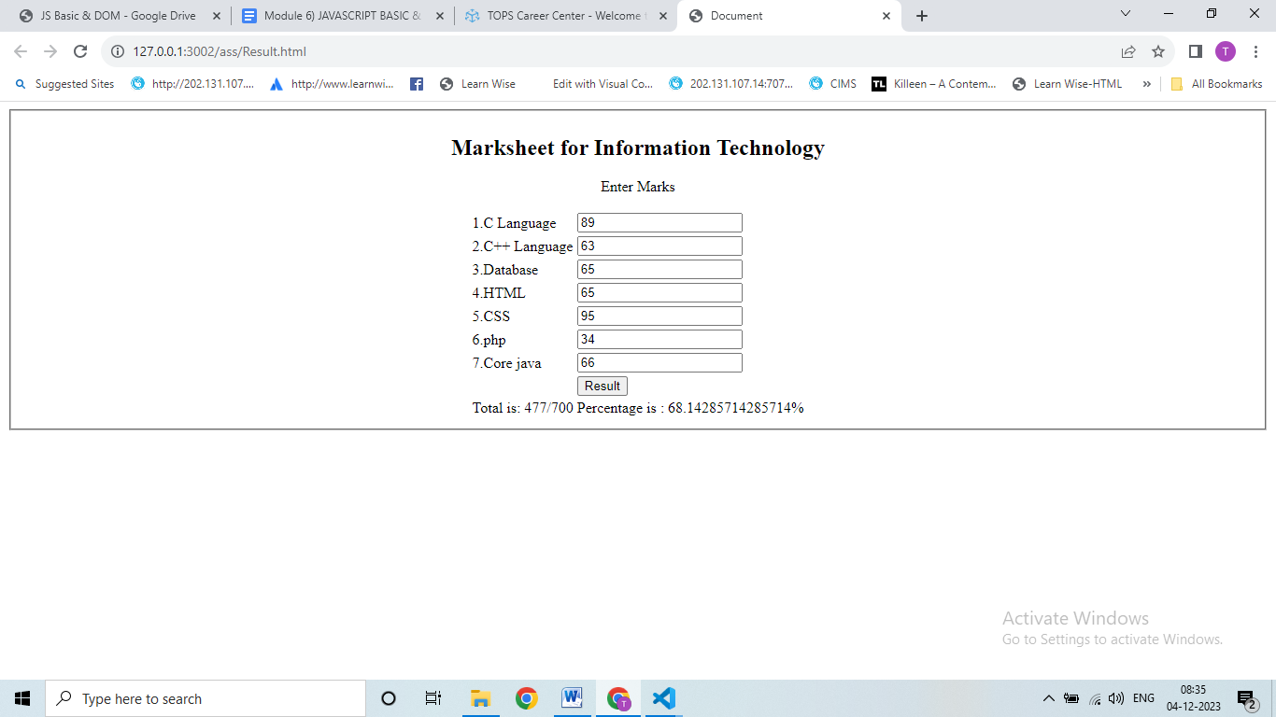

**Que-  Create a slider using JavaScript**

**Ans:**

**<!DOCTYPE html>**

**<html lang="en">**

**<head>**

**<meta charset="UTF-8">**

**<meta name="viewport" content="width=device-width, initial-scale=1.0">**

**<title>Document</title>**

**</head>**

**<style>**

**\* {**

**margin: 0;**

**padding: 0;**

**box-sizing: border-box;**

**}**

**#slider-container {**

**position: relative;**

**max-width: 1500px;**

**margin: auto;**

**overflow: hidden;**

**margin-top: 100px;**

**}**

**#slider {**

**display: flex;**

**transition: transform 0.5s ease-in-out;**

**justify-content: space-around;**

**}**

**.slide {**

**width: 200px;**

**height: 200px;**

**display: flex;**

**align-items: center;**

**justify-content: center;**

**}**

**#prev,**

**#next {**

**position: absolute;**

**top: 50%;**

**transform: translate(-50%);**

**font-size: 20px;**

**cursor: pointer;**

**}**

**#prev {**

**position: relative;**

**margin: 90px 0 0 500px;**

**}**

**#next {**

**position: relative;**

**margin: -27px 0 0 700px;**

**}**

**</style>**

**<body>**

**<div id="slider-container">**

**<div id="slider">**

**<div class="slide" style="background-color: yellow;">Slider 1</div>**

**<div class="slide" style="background-color: red;">Slider 2</div>**

**<div class="slide" style="background-color: rebeccapurple;">Slider 3</div>**

**<div class="slide" style="background-color: green;">Slider 4</div>**

**<div class="slide" style="background-color: blue;">Slider 5</div>**

**</div>**

**<div class="arrow">**

**<div id="prev" onclick="prevSlide()">&#10094;</div>**

**<div id="next" onclick="nextSlide()">&#10095;</div>**

**</div>**

**</div>**

**<script>**

**let currentSlide = 0;**

**const slides = document.querySelectorAll(".slide");**

**const slider = document.getElementById("slider");**

**function showSlide(index) {**

**const newposition = -index * slides[0].offsetWidth;**

**slider.style.transform = `translateX(${newposition}px)`;**

**}**

**function nextSlide() {**

**currentSlide = (currentSlide + 1) % slides.length;**

**showSlide(currentSlide);**

**updateSlideOrder();**

**}**

**function prevSlide() {**

**currentSlide = (currentSlide - 1 + slides.length) % slides.length;**

**showSlide(currentSlide);**

**updateSlideOrder();**

**}**

**function updateSlideOrder() {**

**const slidesArray = Array.from(slides);**

**const adjustedSlides = slidesArray.slice(currentSlide).concat(slidesArray.slice(0, currentSlide));**

**slider.innerHTML = ""; //clear existing slides**

**adjustedSlides.forEach((slide) => slider.appendChild(slide.cloneNode(true)));**

**}**

**showSlide(currentSlide);//Initialize the display**

**</script>**

**</body>**

**</html>**

**OUTPUT:**

